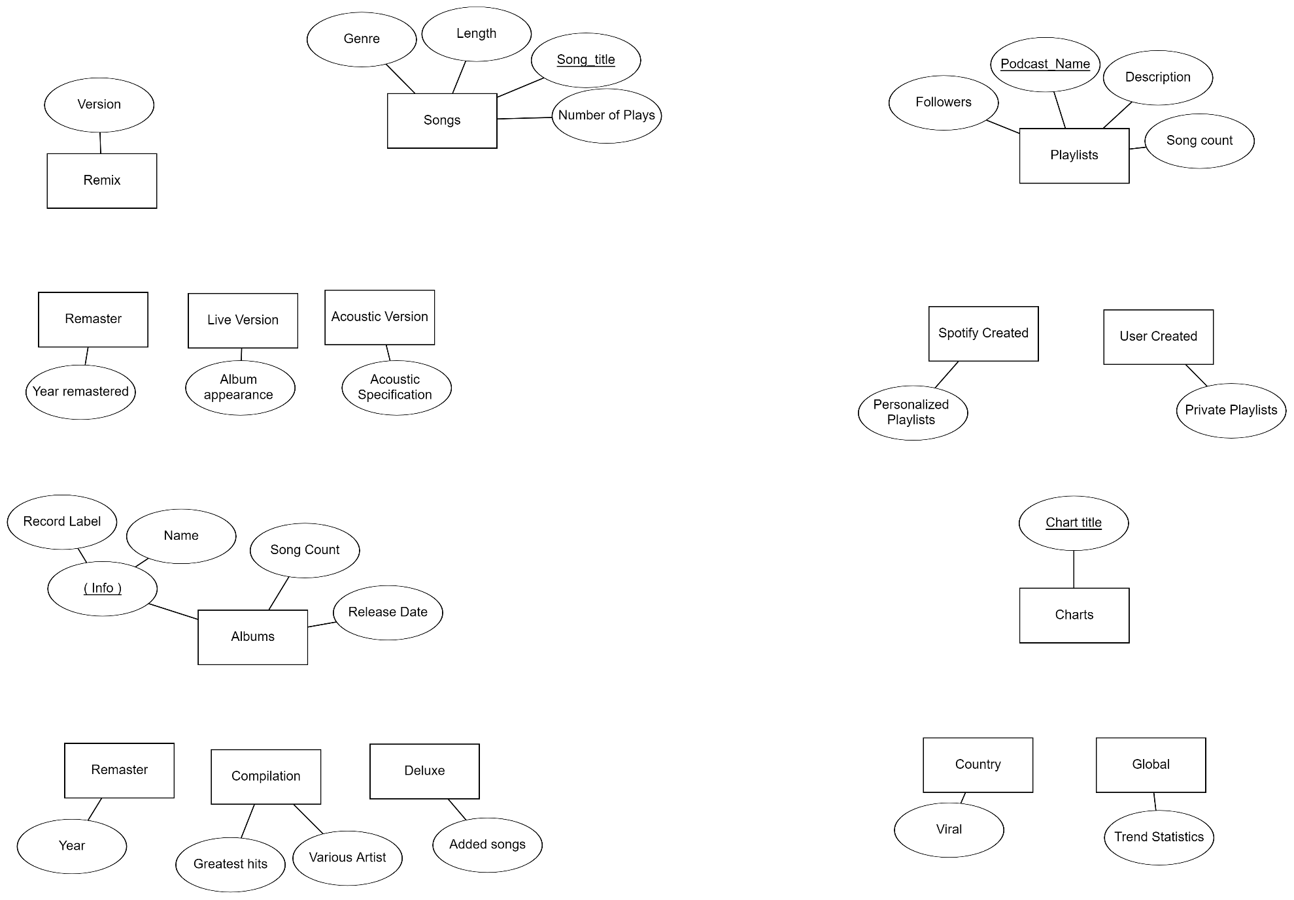

This is overlap since some albums will fit multiple subclasses

This is only a partial relationship since an album doesn’t have to be one of these subclasses.

This is disjoint since a global chart is different than specific country charts

This is a total relationship since charts have to be one of these subclasses.

This is disjoint since a playlist can only be one of these subclasses

This is a total relationship since playlists have to be one of these subclasses.

This is an overlap since some songs can fall into many different subsets.

This is only a partial relationship since a song doesn’t have to be one of these subclasses.

U

U

U

O

U

U

U

U

O

U

U

U

D

U

D